New Zealand International Biology Olympiad (NZIBO)

- Name | New Zealand International Biology Olympiad (NZIBO)
- Established | June 2004
- Logo | 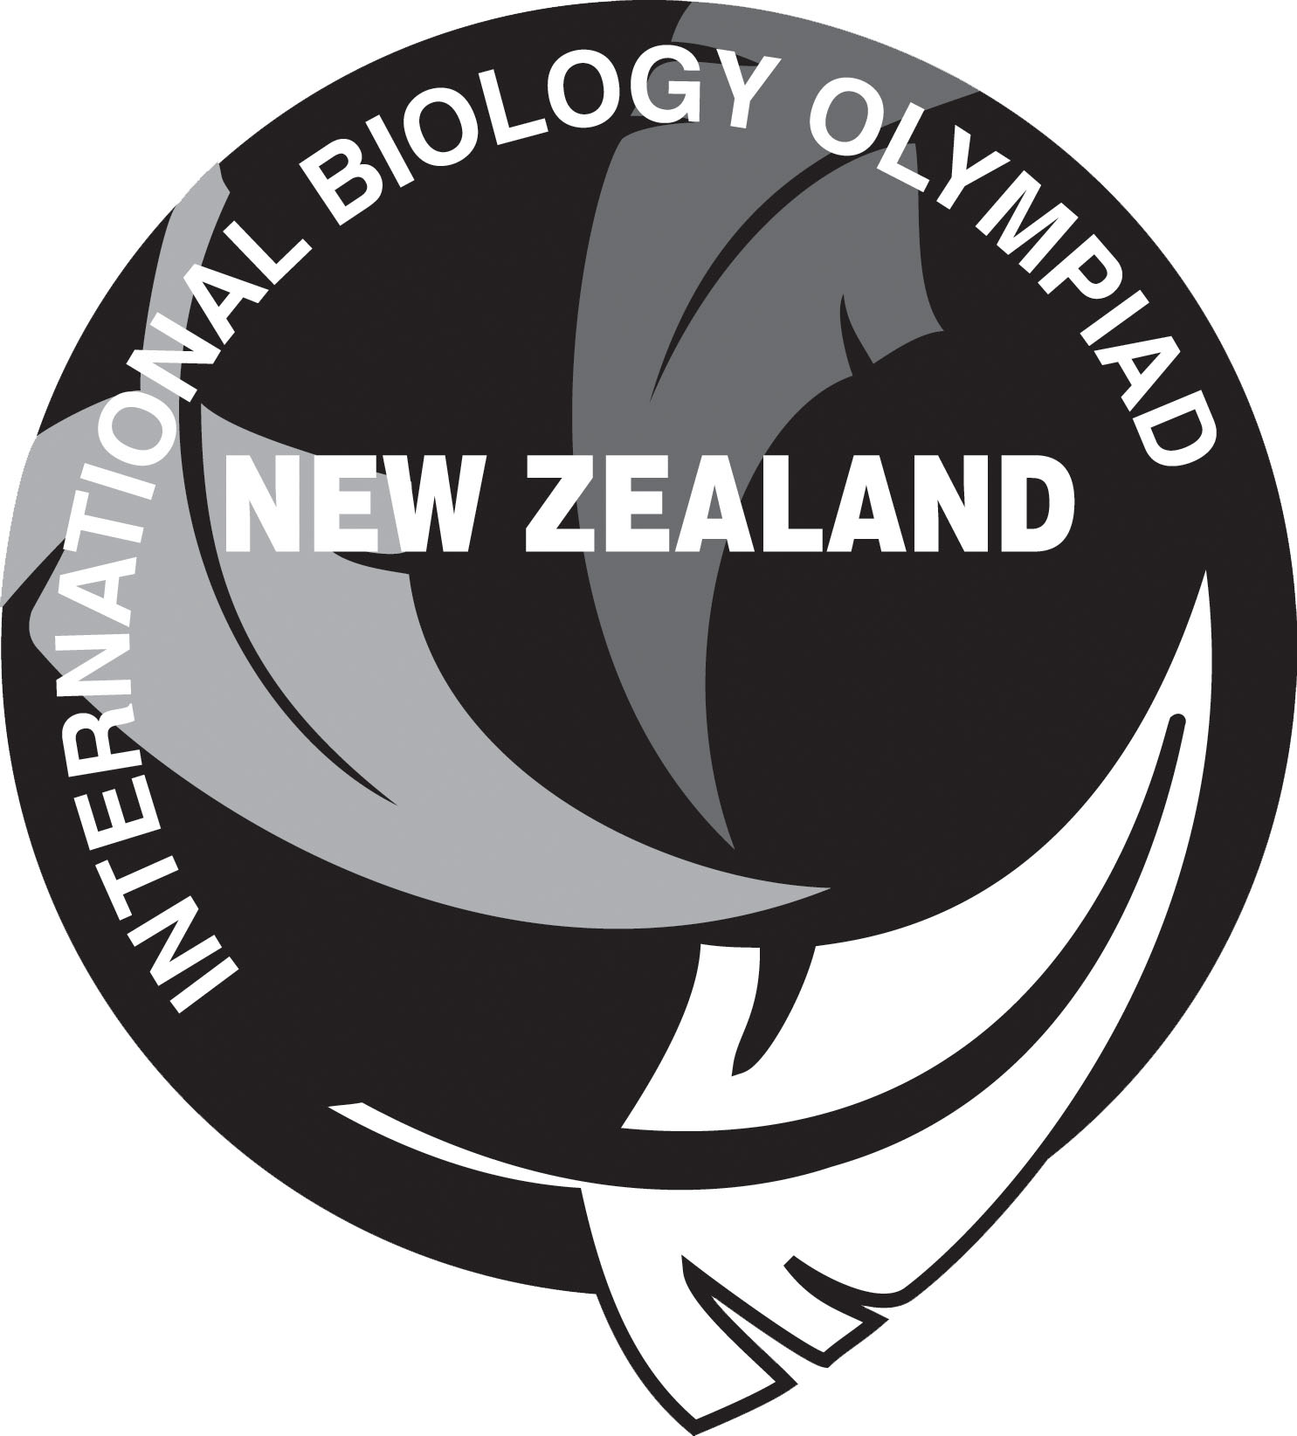
Email Contact for  Registration | nzibo.register@gmail.com
Deadline for registration: | August 5, 2020; online  Entrance exam: Wednesday August 26, 2020
- Website URL | http://www.nzibo.org
- Olympiad promotion (among schools, teachers, press...) | National newsletter, emails via the Royal Society of New Zealand, promotion through the relevant teachers association Biology Educators of New Zealand (BEANZ), mail outs to all schools and all science teachers in New Zealand, presentations at teachers conferences (SCICON, BIOLIVE and BioED),  Facebook: https://www.facebook.com/NZBiologyOlympiad and website: www.nzibo.org
- Exams | August – 2-hour National entrance exam. Multiple choice, resource based and does not require specific curriculum knowledge. This is a national exam and heavily promoted to ensure entrance of students from throughout NZ.  February – 2-hour multi-choice Selection exam, based on 2/3 of the IBO curriculum.  April – A 3-hour practical examinations AND a 3-hour multiple choice theory exam based on the complete IBO curriculum.
- Student training | The top 200 students from the Entrance exam are encouraged to participate in study of the IBO curriculum via online tutorials. They complete a series of directed questions based on the IBO curriculum and then receive feedback on their work. They are encouraged to discuss their understanding of the topics with each other and the tutorial coordinator via a Facebook group. They also complete MasteringBiology assignments from Pearson.  Based on the Selection exam, the top 20-25 students (numbers are financially constrained) are invited to attend a residential training and selection camp for 8 - 10 days. They are hosted by a number of tertiary education providers and complete a variety of practical tasks, fieldwork, and seminars.  At the end of this camp, the students sit the team selection exams and the top 4 students are selected to represent NZ at the annual IBO competition.  Students representing NZ are supported to continue their study until the IBO competition itself and can email NZIBO committee members for help. They are also provided with previous IBO exam questions to direct their study. As these students are spread throughout NZ no further group training occurs.
- Study materials | Campbell Biology: Australian and New Zealand edition, 11th Edition. By Lisa A. Urry, Noel Meyers, Michael L. Cain, Steven A. Wasserman, Peter V. Minorsky, Jane B. Reece.  Older editions are acceptable.
- Awarding of students, prizes | All students receive a Participation Certificate. Students who complete the tutorial programme receive a Bronze Certificate. Students selected to attend the Practical Training and Selection Camp receive a Silver Certificate and those selected to represent NZ at the IBO receive a Gold Certificate. The top student at the IBO receives a Platinum Certificate.
- Financial support / resources | Provided by various tertiary institutions and commercial sponsors. Students also pay a $30 registration fee to sit the national entrance exam, $97 to participate in the tutorial programme and $800 to attend the Practical Training and Selection Camp.
- Support of Min. of Education | Students representing NZ receive a financial contribution towards the cost of their travel from the Royal Society of New Zealand via the Talented School Students Travel Award. The NZIBO programme receives no financial support from the Ministry of Education and is run entirely by volunteers.
- National Competition Rules | By the time of the IBO in July of the following year students participating in the NZIBO programme must:  (1) be born by the 1st of July or later of the actual IBO year minus twenty.  (2) be in full-time attendance at a secondary school in NZ.  (3) have attended school in NZ for at least 2 years.  (4) have not already participated twice in the IBO.  (4) have not obtained a diploma allowing study at a university or equivalent institution before the 1st of January of the actual competition year.  (5) have not yet started study at a university or equivalent institution as regular or full-time students.
- Selection procedure for IBO competition | Outlined above. The top four students are picked based on their grades in the final theory and practical examinations held during the Practical Training and Selection Camp as well as their commitment to the tutorial programme.
- Executive committee | Dr A Sharples Chairperson (2006 -), Executive committee member (2004 - ) Team Leader 2005-08, 2010-12, 2014, 2017, 2019.  Dr H Meikle, Secretary (2003 -), Registration, Team Leader 2007, 2009, 2013, 2015, 2017, 2019.  Ms P Casey, Treasurer (2013 - ), Team Leader 2014, 2016.  Mr R Hendra, Tutorial Programme Coordinator 2014 -,  Team Leader 2011, 2013.  Mr N Bryant, Practical Training Camp Coordinator. Team Leader 2015  Mr S Cooper, Practical Training Camp Coordinator, Auckland; Team Leader 2014, 2016, 2018  Mrs P Daddy, Team Leader 2018  Ms M Isbister, Camp Leader, Observer 2019
- IBO coordinator (name address, email) | Dr A Sharples  896A State Highway 5  RD2  Rotorua 3072  NEW ZEALAND  sharples@farmside.co.nz
- Statistics over the years | Participation: Medal tally:  2004/05 77 2 Bronze medals  2005/06 156 2 Bronze medals  2006/07 145 1 Silver and 2 Bronze medals  2007/08 137 1 Silver and 3 Bronze medals  2008/09 215 1 Silver and 2 Bronze medals  2009/10 242 2 Silver and 2 Bronze medals  2010/11 276 1 Gold, 1 Silver and 1 Bronze medals  2011/12 242 1 Silver and 2 Bronze medals  2012/13 389 4 Bronze medals  2013/14 344 2 Silver, 2 Bronze medals  2014/15 374 1 Silver, 2 Bronze medals  2015/16 349 3 Silver,1 Bronze medal  2016/17 347 1 Gold, 3 Bronze medals  2017/18 347 Did not compete at IBO  2018/19 326 2 Silver, 1 Bronze  2019/20 - Cancelled as a result of COVID-19

